Nama : Meiysa Rifka Amelia

NIM : 09010182327017

Kelas : MI 3A

Matkul : Praktikum Jaringan Komputer

**LAPORAN**

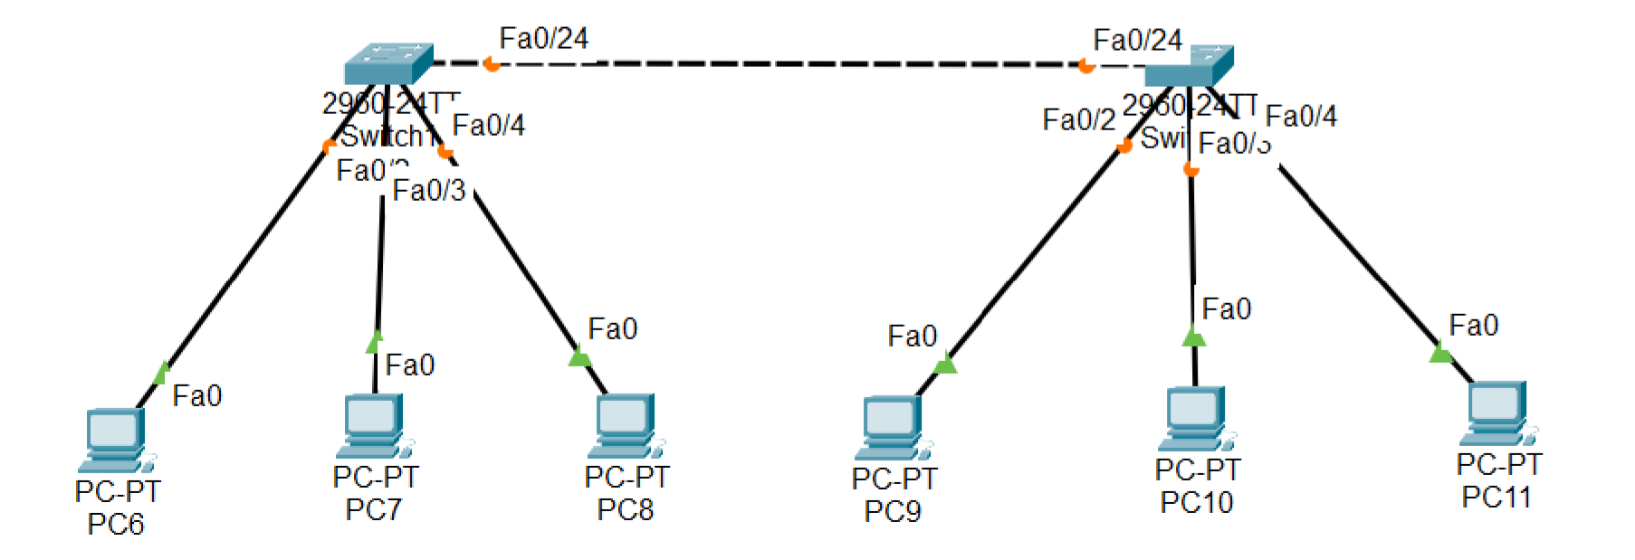

**SWITCH VTP**

**SERVER**

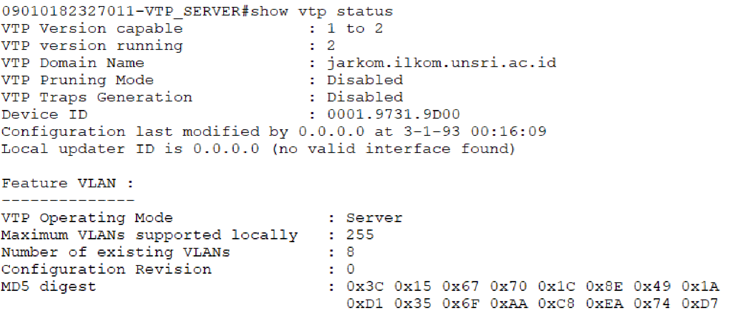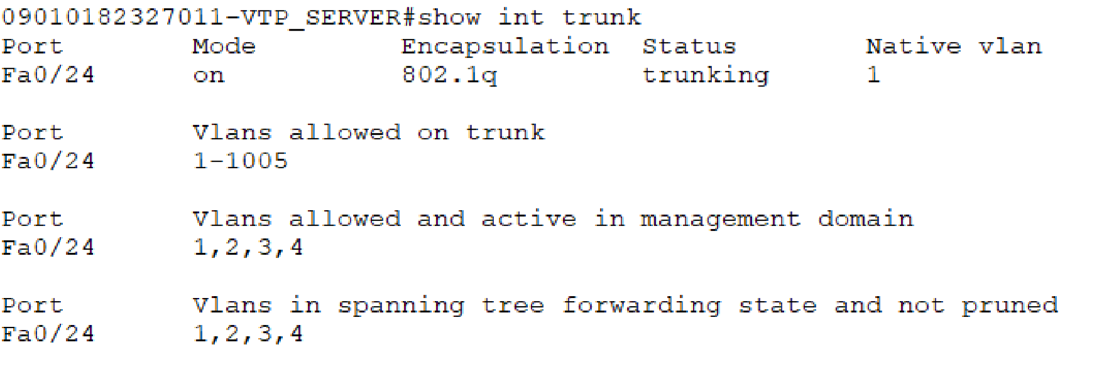

**SWITCH VTP**

**CLIENT**

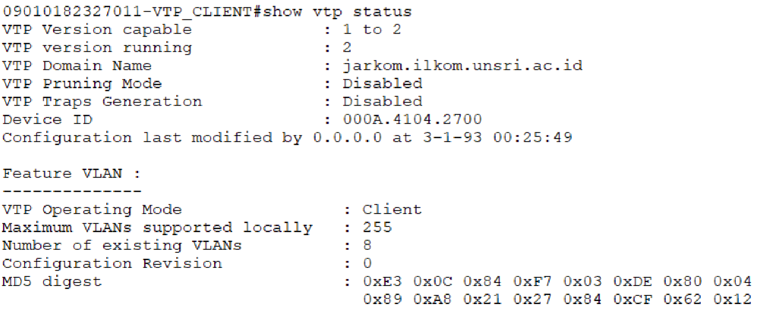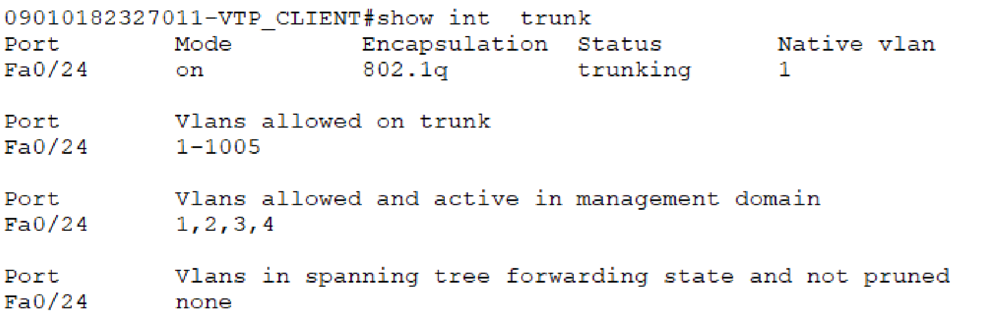

**TUGAS**

 **NAT PERCOBAAN**

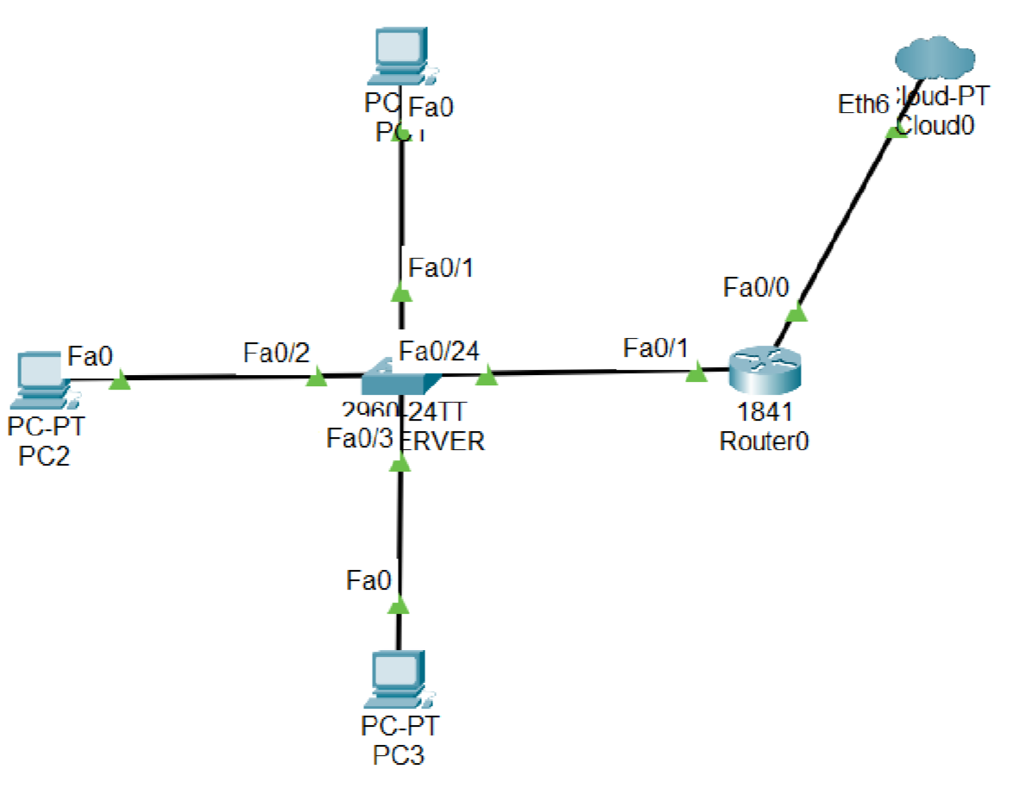

1. **KONFIGURASI SWITCH**

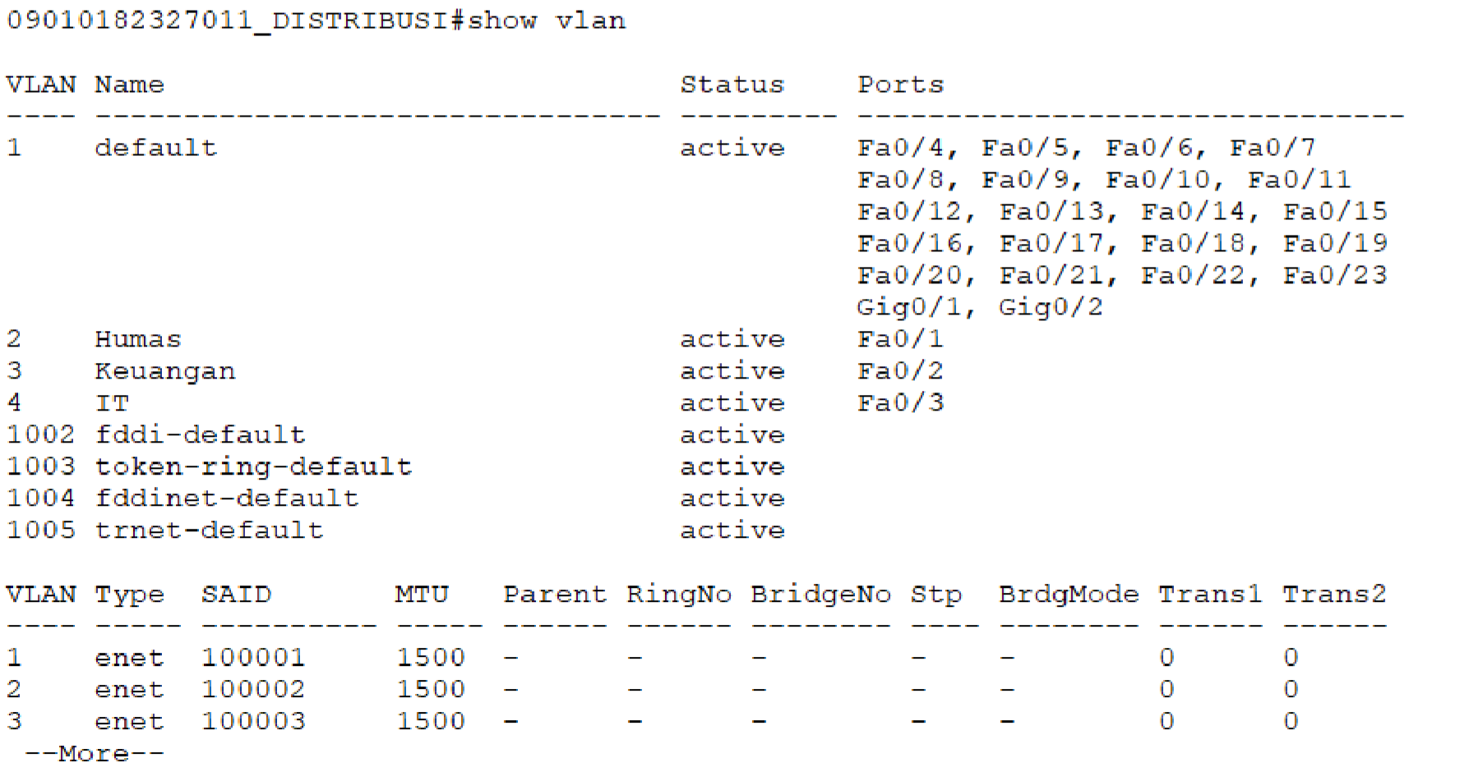

|  |  |  |  |
| --- | --- | --- | --- |
| **VLAN** | **NAME** | **STATUS** | **PORTS** |
| 1 | default | active | Fa0/4, Fa0/5, Fa0/6, Fa0/7  Fa0/8, Fa0/9, Fa0/10, Fa0/11  Fa0/12, Fa0/13, Fa0/14, Fa0/15  Fa0/16, Fa0/17, Fa0/18, Fa0/19  Fa0/20, Fa0/21, Fa0/22, Fa0/23  Gig0/1, Gig0/2 |
| 2 | Humas | active | Fa0/1 |
| 3 | Keuangan | active | Fa0/2 |
| 4 | IT | active | Fa0/3 |
| 1002 | Fddi-default | active |  |
| 1003 | Token-ring-default | active |  |
| 1004 | Fddinet-default | active |  |
| 1005 | trnet-default | active |  |

1. **KONFIGURASI ROUTER**

**Melihat Daftar IP dari Client**

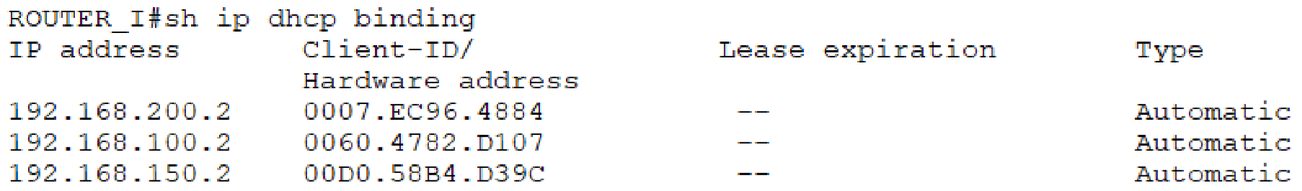

|  |  |  |  |  |
| --- | --- | --- | --- | --- |
| **NO** | **IP ADDRESS** | **MAC ADDRESS** | **LEASE EXPIRATION** | **TYPE** |
| 1 | 192.168.200.2 | 0007.EC96.4884 | __ | Automatic |
| 2 | 192.168.100.2 | 0060.4782.D107 | __ | Automatic |
| 3 | 192.168.150.2 | 00D0.58B4.D39C | __ | Automatic |

**Daftar IP Client**

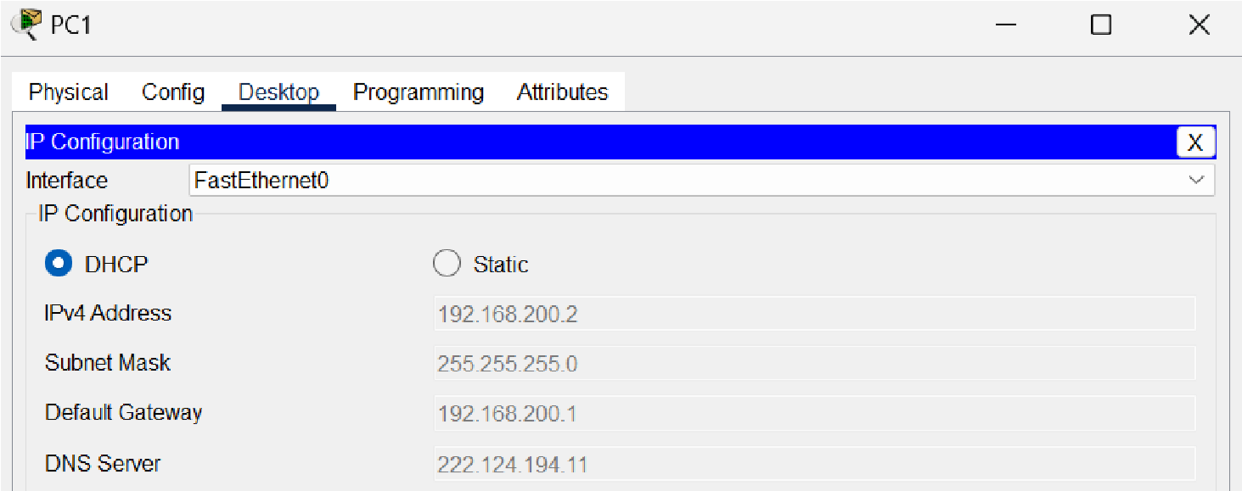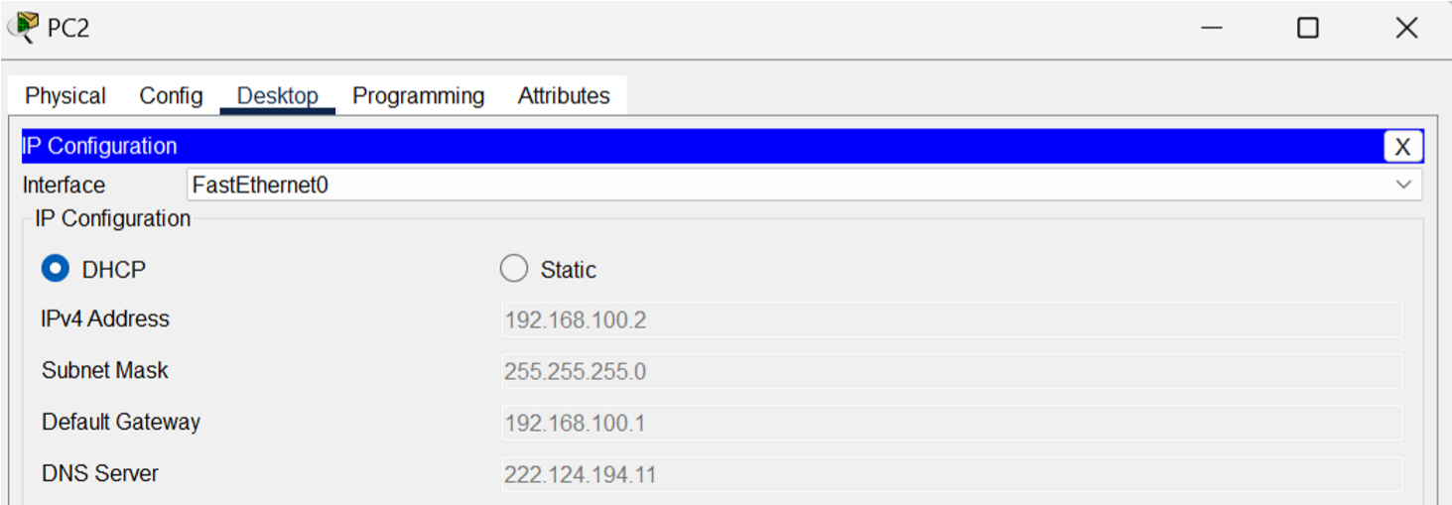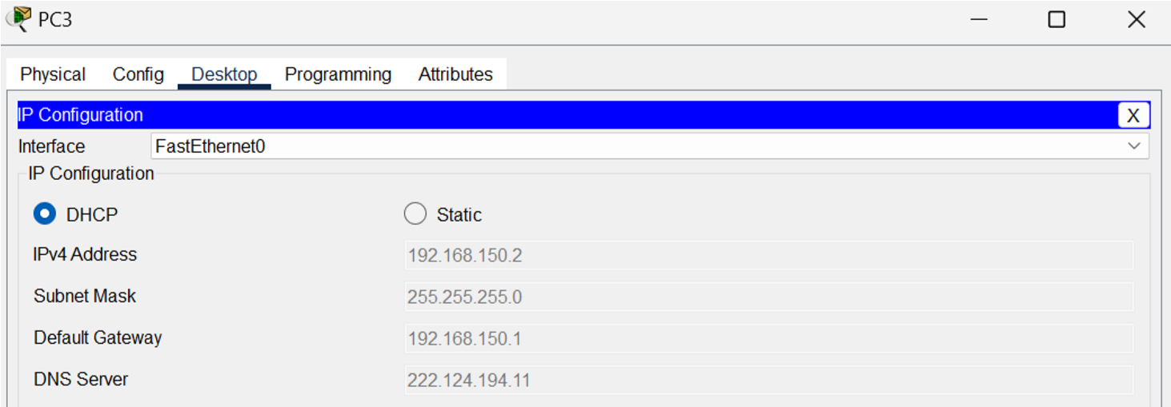

|  |  |  |  |  |  |
| --- | --- | --- | --- | --- | --- |
| **NO** | **CLIENT** | **IP ADDRESS** | **NETMASK** | **GATEWAY** | **DNS** |
| 1 | PC 1 | 192.168.200.2 | 255.255.255.0 | 192.168.200.1 | 222.124.194.11 |
| 2 | PC 2 | 192.168.100.2 | 255.255.255.0 | 192.168.100.1 | 222.124.194.11 |
| 3 | PC 3 | 192.168.150.2 | 255.255.255.0 | 192.168.150.1 | 222.124.194.11 |

**Tes Koneksi Ke sebuah website (catat hasil yang anda dapat)**

